**Solution Document**

**Wells Fargo .net Technical Homework**

**Order Management System**

The given .Net Technical Homework designed and developed to upload the transactions and the look up metadata file to process the portfolios Order Management and generated new the output file for the different order management using swagger interface, where the user should be able to upload the portfolio transactions csv file and the metadata file.

The uploaded file will be stored inside API project **Files** folder and the generated Order management system output file with the specific extension and the file formats.

The Order Management System solution which has **C# code to process input files** and **C# code to test your solution**  can be accessed from the GitHub

**Swagger API Homepage Interface**

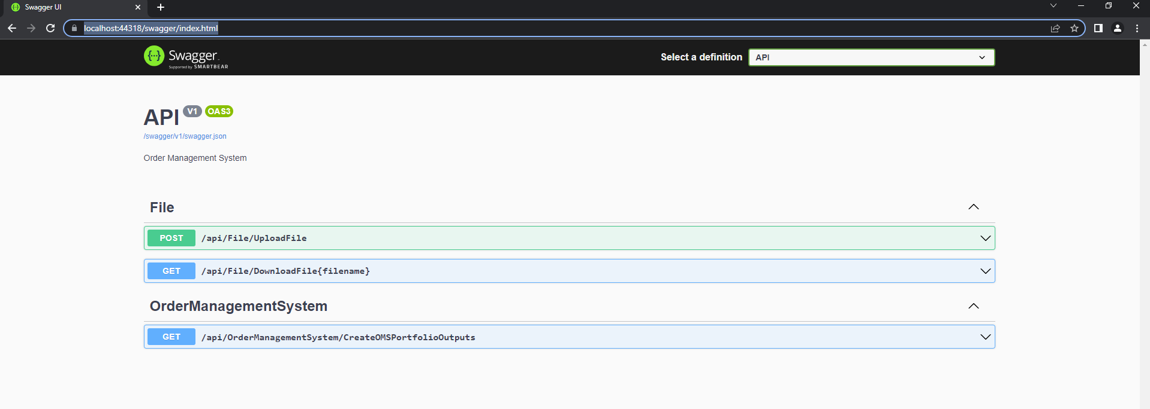

**File Upload API endpoint**

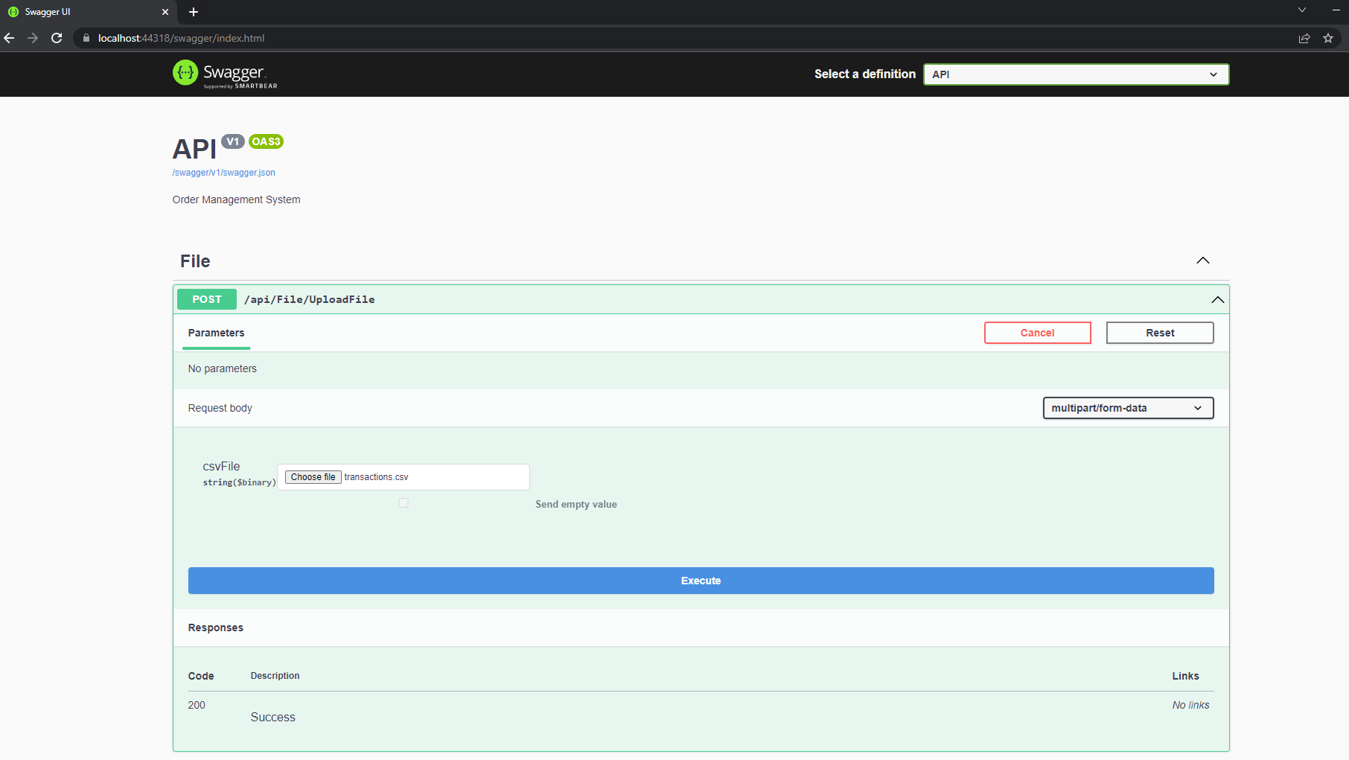

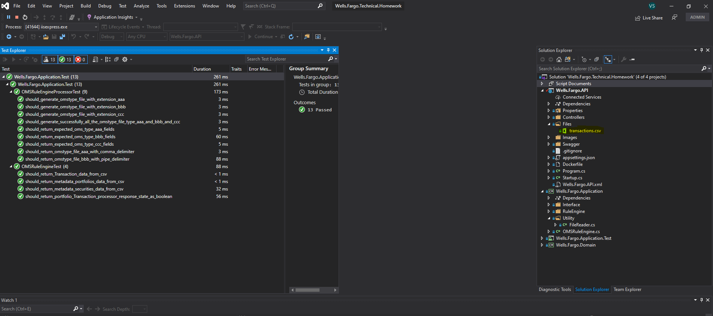

**Order Manager System Output file generate API**

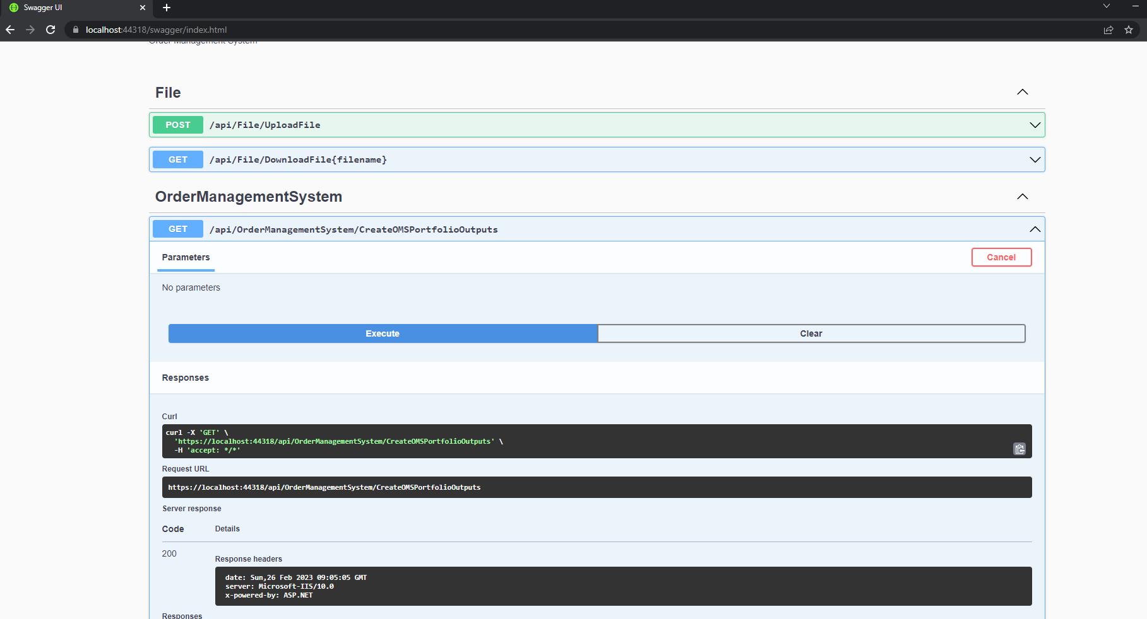

**Generated Different Order Management System Output File**

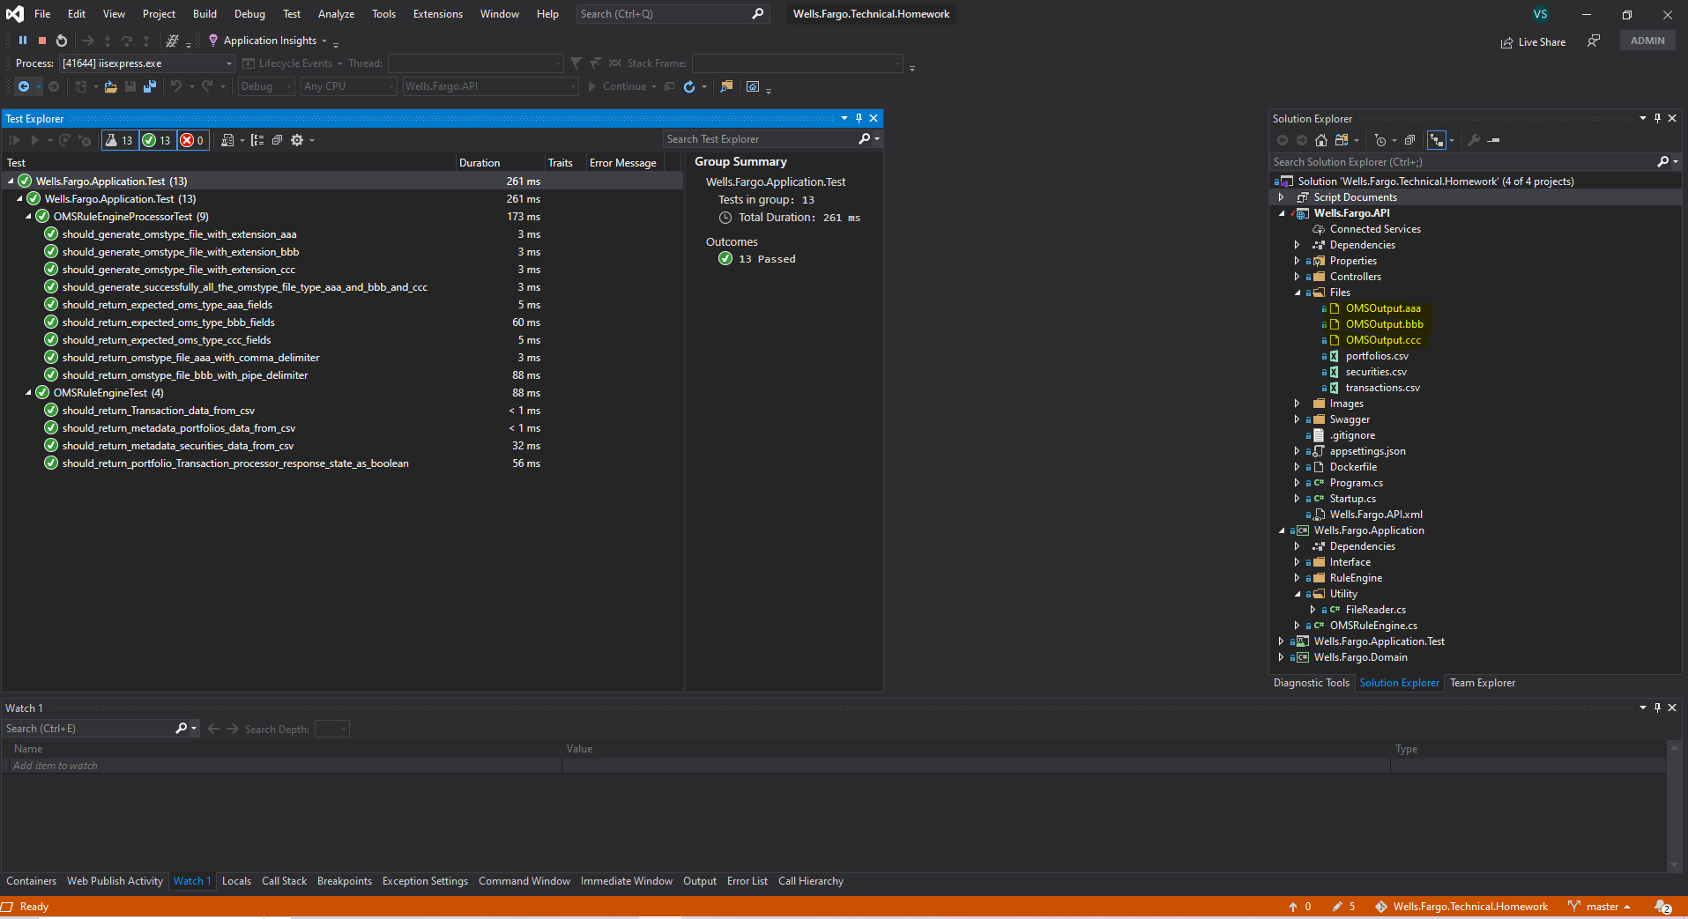

**File Downloading API endpoint to download the generated OMS output file**

